1
2

3
4
5
6
7
8
9
10
11
12

Task №1. Puzzle time

- широкий 7. мост
- башня 8. королева
- площадь 9. столица
- колокол 10. король
- дворец 11. ворон
- памятник 12. тюрьма

Task № 2. Let’s practice English grammar.

Write “the” where it is necessary.

_____ London _____ Queen Victoria Memorial
_____ St Paul’s Cathedral _____ Westminster Abbey
_____ Trafalgar Square _____ Houses of Parliament
_____ Tower of London _____ Oxford Street
_____ National Gallery _____ Tower Bridge
_____ William ______ Conqueror _____ Big Ben
_____ Thames _____ Hyde Park
_____ Buckingham Palace _____ Admiral Nelson
_____ Romans _____ City
------------------------------------------------------------------------
Task №3. Sights of London

Parts of London | The numbers of the pictures
The City
Westminster
1.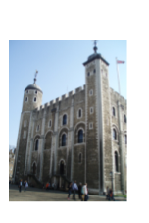 2. 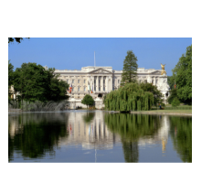 3.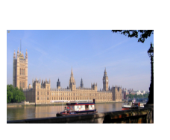 4.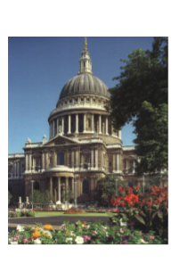 5. 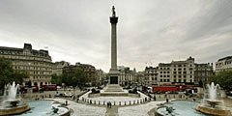 6. 