Lesson Plans
LESSON: Unit 3 Living things. Animals. |  |  | School: № 7 Y.A. Gagarin
Date: |  |  | Teacher name: Дадашева Лариса Узеировна
CLASS: 5 |  |  | Number present:
Learning objectives(s) that this lesson is contributing to |  | 5.R4 read with some support a limited range of short fiction and non-fiction texts  5.UE9 use simple present and simple past regular and irregular forms to describe routines, habits and states on a limited range of familiar general and curricular topics  5.S6 communicate meaning clearly at sentence level during, pair, group and whole class exchanges
Plan
Planned activities |  |  |  |  | Resources
Warm-up  Teacher shows a picture on PPT and asks learners: Which word can you spell? (slide 1) Learners should spell the word correctly, then teacher can introduce the topic of the lesson.  Teacher asks learners: What can you see on the picture? (slide 2) Teacher checks their knowledge of how they know the names of some animals.  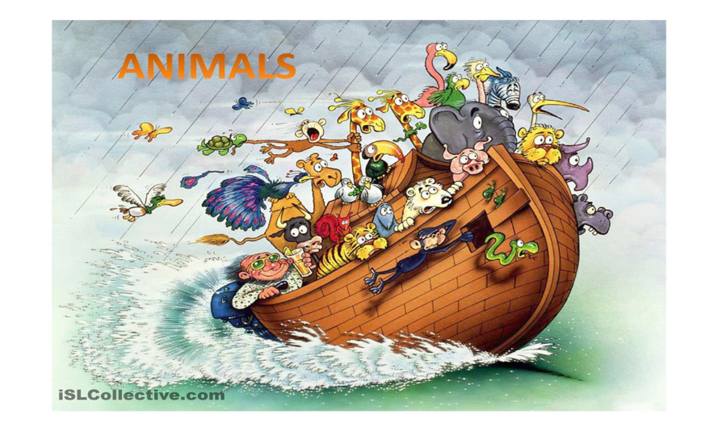  Then teacher lets the learners know the LO of the lesson. (slide 3)  Teacher starts a word snake on the board using animals, to continue the snake learners have to use the last letter of the following word. (open class activity)  Ex: cat-tiger-rabbit-turtle-elephant-etc.  Pre-learning  - Learners are divided into small groups and asked to brainstorm and write any animals they know in 2 min and then learners name the animals they have written.  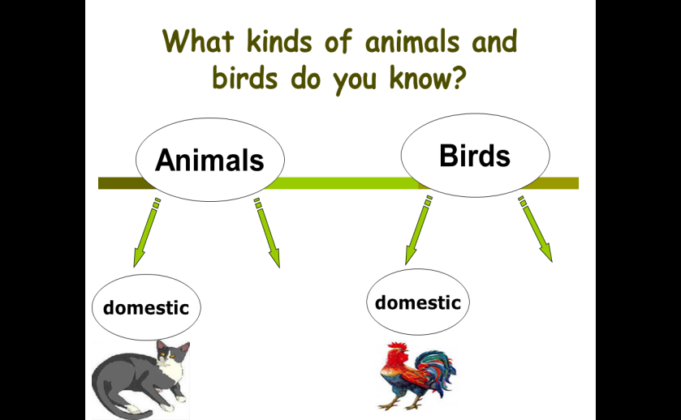  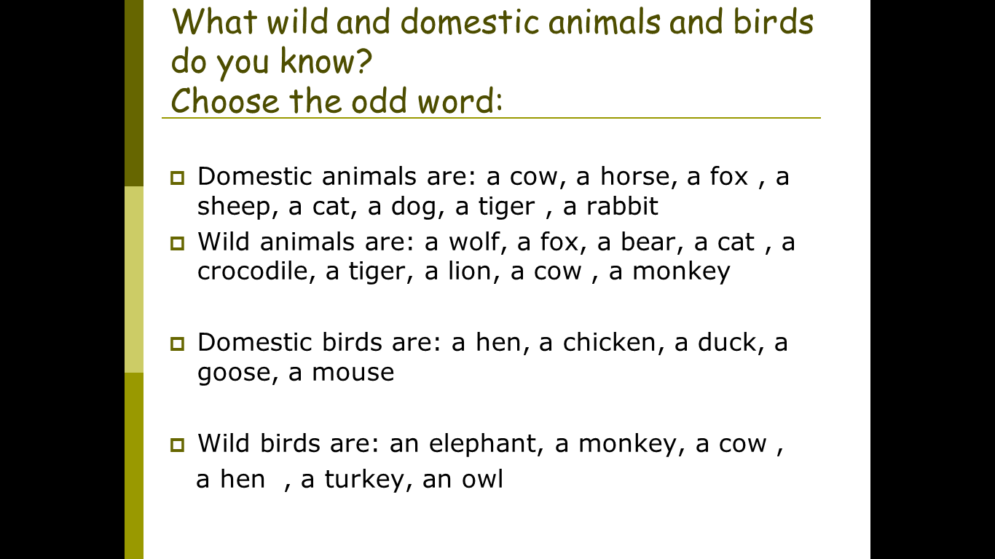  Work with words.  - Teacher distributes the handout with animal flashcards and asks learners to match words to the pictures on the board. (Differentiation by support, more able learners with learners who need support). Other learners should check the words Teacher focuses on pronunciation and spelling the words correctly. (Peer based assessment)  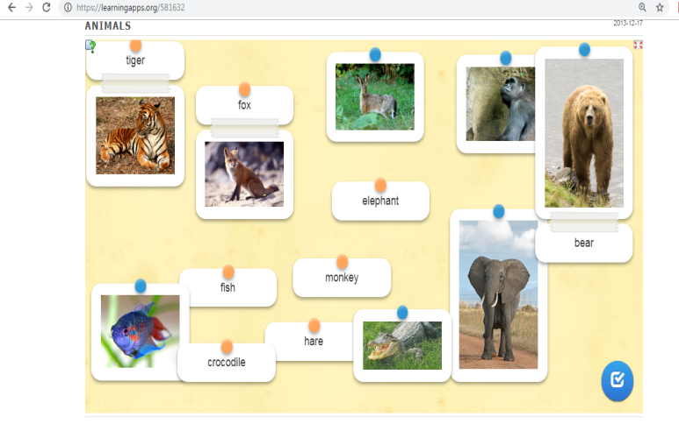  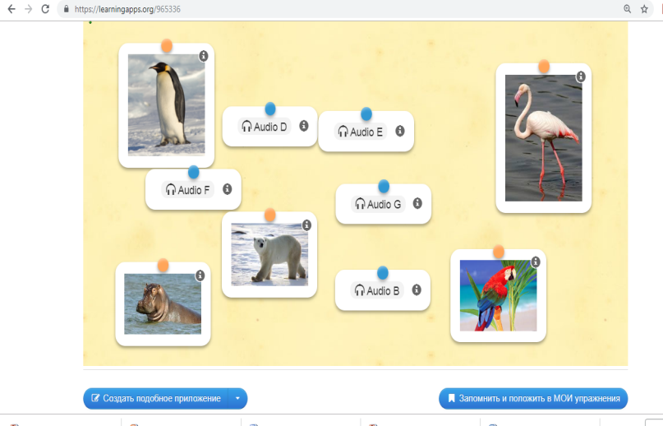 |  |  |  |  | PPT  Flashcards
- Teacher divides learners work groups, e.g. kangaroo (student A), tigers (student B), lions (student C)  Group work  - Teacher introduces the text about animals, for Kangaroo’s group teacher gives the text about Kangaroo, for Tiger’s group, text about Tiger, and for Lion’s text about Lions. Leaners will read in groups, and underline the unfamiliar words and ask each other or teacher can help them. After that, learners should exchange their text with other groups, so learners will read the facts about these three types of animals.  Hot Chair activity.  Teacher takes an empty 3 chairs – one for each team- and puts them in front of the class, facing the team members. Teacher explains to the learners that these chairs are the hot chairs. Then get one member from each team to come up and sit in that chair, so they are facing their teammates, learners should ask questions about animals the learners who sit on the chair. The first hot chair learner to answer the question and wins a point for their team. Teacher monitors, takes notes and assesses learner’s answers. (Teacher based assessment)  To support learners teacher can provide a list of questions on the board as an example:  1. Where do kangaroos live?  2. What do they eat?  3. How big are they?  4. How many babies do they have? |  |  |  |  | Worksheet 1,2,3
End  36-40 | - Learners complete an evaluation of what they did during the lesson by circling one word in each statement:  I can understand: all / most of / some of the text in the website. .  I can tell about an animal very well/ well/not bad
Директор МКОУ «Аваданская СОШ» __________ Махмудов М. Г.

